SIMATS ENGINEERING
ASSESSMENT TOOL III — TIME-SERIES & GEOSPATIAL ANALYSIS REPORT

Course: Data Handling and Visualization | Code: DSA0603 | CO: CO4
Duration: 60 min | Total Marks: 50 | Reg No: 192424238  Name: Jayaprakash Nivas

COURSE OUTCOME COVERED
Apply appropriate visualization techniques to analyze time series data, detect trends, seasonality, and cyclical patterns. (BL3)
CO3 Construct and interpret geospatial visualizations, including static, cartogram-based, and interactive representations. (BL3)
Activity Tool : Time-Series & Geospatial Analysis Report Weightage: 20%

Code of Conduct:
I Jayaprakash Nivas (192424238) (Name / Reg No) certify that this submission is my original work and that I have adhered to the guidelines specified for this assessment. I understand that any violation of academic integrity rules will result in disciplinary action.

Signature of the student:

Criteria | Data Understanding & Preparation 25% | Time-Series/Geospatial Analysis  25% | Application of Visualization Techniques 20% | Report Organization 15% | Accuracy 10% | Clarity 5% | Total
Q1
Q2
Q3
Q4
Q5

Time-Series & Geospatial Analysis Report
Topics: Individual & Multiple Time Series, STL Decomposition, Smoothing & Detrending, Forecasting, Cycle/Seasonality Detection | Choropleth Maps, Cartograms, Interactive Geospatial Plots, Projections & Layers, 3D Geospatial Visualization

Note: Questions 1–4 are to be completed in R. Question 5 must be completed in Python.

Provided Datasets
The following files are supplied alongside this document. All are real, publicly documented datasets:
- Nile.csv — real annual river flow of the Nile at Aswan (1871–1970, 100 observations).
- AirPassengers.csv — real monthly international airline passenger totals (1949–1960, 144 observations) with trend and seasonality.
- USArrests.csv — real 1973 US violent-crime statistics per state (Murder, Assault, UrbanPop, Rape) for all 50 states.
- state_x77.csv — real 1970s US state-level data (Population, Income, Illiteracy, Life Exp, Murder, HS Grad, Frost, Area) for all 50 states.
- quakes.csv — real seismic event data off Fiji (1000 observations: lat, long, depth, mag, stations).
- volcano_elevation.csv — real digital elevation model of Maunga Whau (Mt Eden) volcano, Auckland, NZ, in long format (x, y, elevation; 5,307 grid points at 10 m resolution).
Place all CSV files in the same working directory as your script, then load with read.csv() in R or pandas.read_csv() in Python.

Question 1: Individual Time Series — Smoothing & Detrending

Language: R
Dataset provided: Nile.csv
Convert the value column into an R ts object (start = 1871, frequency = 1) and plot the raw annual flow as a line chart. Overlay a 5-year moving-average smoother (stats::filter() or zoo::rollmean()). Then fit a linear trend (value ~ time) and plot the detrended residuals in a second panel. Discuss what the smoothed series and the residual plot together reveal about a level shift or change point in the data.
Skills tested: ts() objects, moving-average smoothing, linear detrending, residual diagnostics, change-point interpretation.

Code :
data<-Nile
nile_ts<-ts(data,start=1871,frequency=1)
moving_avg<-filter(nile_ts,rep(1/5,5),sides=2)
time<-as.numeric(time(nile_ts))
model<-lm(as.numeric(nile_ts)~time)
trend<-fitted(model)
residuals<-as.numeric(nile_ts)-trend
par(mfrow=c(2,1))
plot(time,as.numeric(nile_ts),type="l",main="Nile Annual River Flow",xlab="Year",ylab="Flow")
lines(time,as.numeric(moving_avg),type="l",col="red",lwd=2)
plot(time,residuals,type="l",main="Detrended Nile Residuals",xlab="Year",ylab="Residuals")
abline(h=0,col="black")
Output :
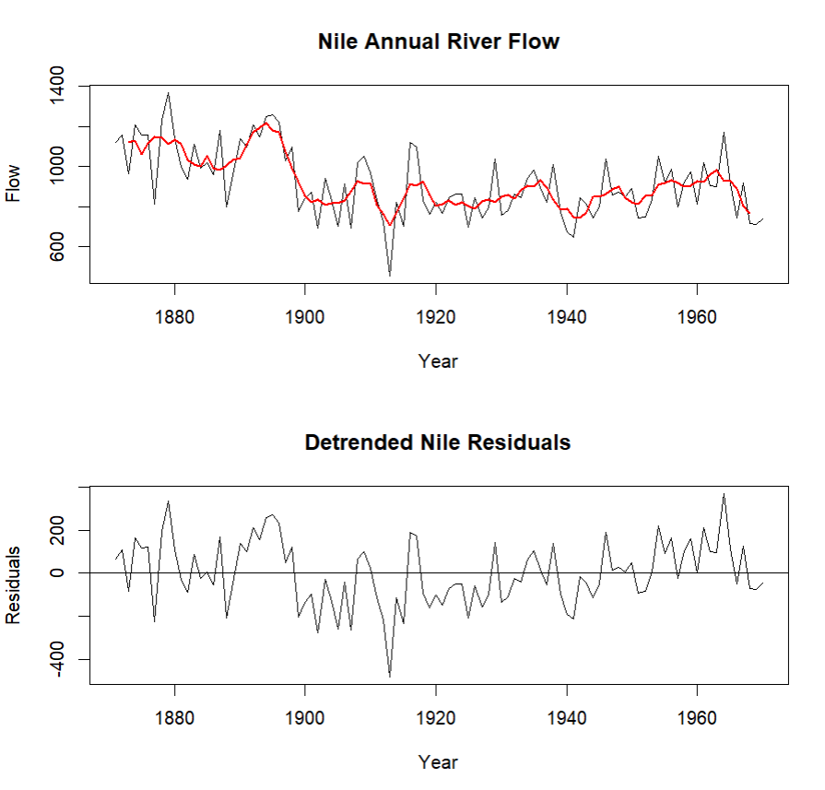
Observation :
The 5-year moving average smooths the short-term fluctuations and makes the long-term pattern easier to observe. The residual plot shows fluctuations around the fitted trend and indicates a noticeable level shift around the late 1890s.

Question 2: Seasonal Decomposition (STL) & Forecasting

Language: R
Dataset provided: AirPassengers.csv
Convert the passengers column into a ts object (start = c(1949,1), frequency = 12). Apply STL decomposition (stl(), s.window = "periodic") and plot the trend, seasonal, and remainder components. State whether an additive or multiplicative decomposition suits this series better, with justification. Then fit an
ETS or auto.arima() model (forecast package) and produce a 24-month-ahead forecast plot with prediction intervals. Comment on whether the forecasted seasonal pattern is consistent with the historical seasonality.
Skills tested: stl(), additive vs. multiplicative decomposition, forecast::ets()/auto.arima(), forecast intervals, seasonality validation.

Code :
library(forecast)
data<-AirPassengers
passengers_ts<-ts(data,start=c(1949,1),frequency=12)
stl_result<-stl(passengers_ts,s.window="periodic")
plot(stl_result)
model<-auto.arima(passengers_ts)
forecast_result<-forecast(model,h=24)
plot(forecast_result,main="24-Month AirPassengers Forecast",xlab="Year",ylab="Passengers")
print(forecast_result)
Output :
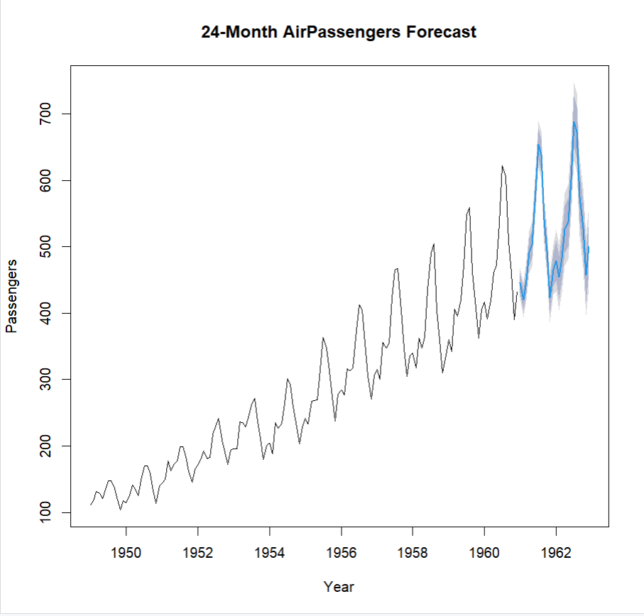

Forecast Interpretation :
The 24-month forecast continues the increasing trend and preserves the strong yearly seasonal pattern observed in the historical data. The prediction intervals become wider further into the future, indicating increasing forecast uncertainty.

Question 3: Choropleth Map & Interactive Geospatial Plot This question has two parts.
Part a — Choropleth Map

Language: R
Dataset provided: USArrests.csv
Join USArrests.csv to US state boundary polygons (e.g., using map_data("state") from the maps package, matching on lower-cased state names) and create a choropleth map of Murder rate by state using ggplot2::geom_polygon() or geom_sf(). Use a sequential color scale and add a legend, title, and a brief caption. Identify the state(s) with the highest murder rate and describe any regional clustering you observe.
Code :
library(ggplot2)
library(maps)
data<-USArrests
data$state<-tolower(rownames(data))
states<-map_data("state")
map_data_final<-merge(states,data,by.x="region",by.y="state")
ggplot(map_data_final,aes(x=long,y=lat,group=group,fill=Murder))+geom_polygon(color="black")+coord_fixed(1.3)+scale_fill_gradient(low="white",high="red")+labs(title="Murder Rate by State",fill="Murder Rate",caption="Source: USArrests dataset")+theme_void()
highest<-rownames(data)[data$Murder==max(data$Murder)]
lowest<-rownames(data)[data$Murder==min(data$Murder)]
print(paste("Highest Murder rate:",paste(highest,collapse=", ")))
print(paste("Lowest Murder rate:",paste(lowest,collapse=", ")))
Output :
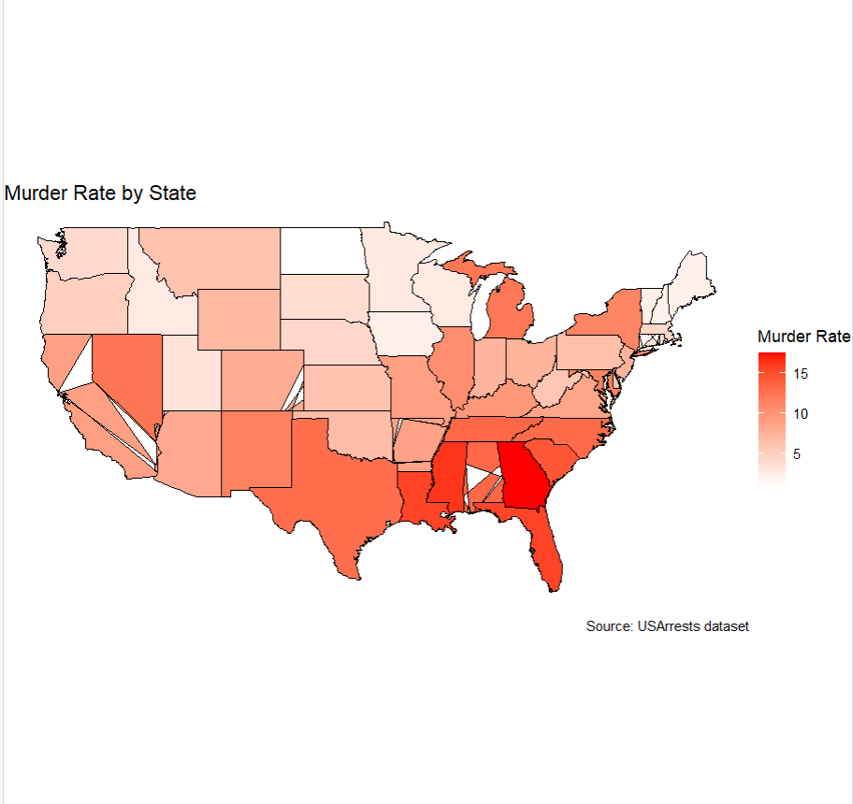

Interpretation :
The choropleth map shows variation in Murder rates across the United States. Higher Murder rates are concentrated more strongly in parts of the southern region, while several northeastern and western states show comparatively lower rates. The states with the highest Murder rates can be identified from the R output.
Part b — Interactive Geospatial Plot

Language: R
Dataset provided: quakes.csv
Using the leaflet package, plot the earthquake locations as circle markers on an interactive map, sizing each marker by mag and coloring by depth (e.g., using colorNumeric()). Add popups showing magnitude and depth on click. Briefly describe any spatial clustering of high-magnitude events.
Skills tested: geom_polygon()/geom_sf() choropleths, sequential color scales, leaflet::addCircleMarkers(), colorNumeric(), interactive popups, spatial clustering interpretation.
Code :
library(leaflet)
data<-quakes
pal<-colorNumeric(palette="YlOrRd",domain=data$depth)
leaflet(data)%>%addTiles()%>%addCircleMarkers(lng=~long,lat=~lat,radius=~mag,popup=~paste("Magnitude:",mag,"<br>Depth:",depth),color=~pal(depth),fillOpacity=0.7)

Output :
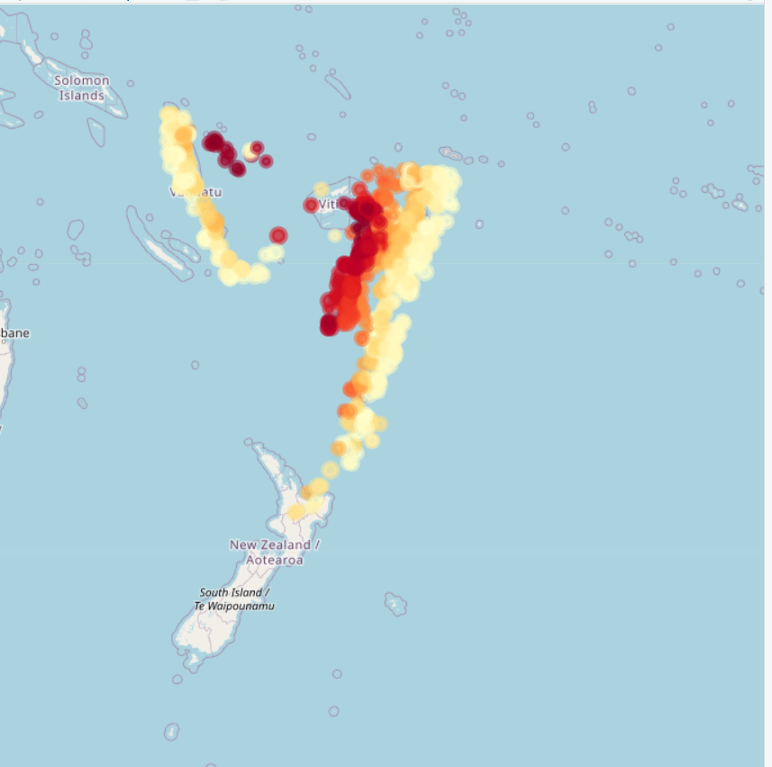

Interpretation
The earthquake locations show spatial clustering rather than being uniformly distributed. High-magnitude events can be identified by the larger markers, and their distribution can be compared with earthquake depth using the marker colors.

Question 4: Cartogram with Map Projections

Language: R
Dataset provided: state_x77.csv (join to US state boundary polygons, e.g. via the maps package)
Join state_x77.csv to US state boundary polygons and construct a population-weighted cartogram using the cartogram package (cartogram_cont() or cartogram_ncont(), sf-based workflow), distorting each state's area in proportion to its Population. Render the cartogram alongside a standard (undistorted) choropleth of the same Population variable, using two different projections for the standard map (e.g., coord_sf(crs = ...) with an Albers equal-area projection vs. a simple longitude/latitude projection). Discuss how the cartogram changes the visual impression of which states appear "large" compared to the standard map, and how the choice of projection affects the standard map's shape.
Skills tested: sf workflows, cartogram_cont()/cartogram_ncont(), coord_sf() and projections (CRS), comparing distorted vs. true-area representations.
Code :
library(ggplot2)
library(maps)
data<-as.data.frame(state.x77)
data$state<-tolower(rownames(data))
states<-map_data("state")
map_data_final<-merge(states,data,by.x="region",by.y="state")
ggplot(map_data_final,aes(x=long,y=lat,group=group,fill=Population))+geom_polygon(color="black")+coord_fixed(1.3)+scale_fill_gradient(low="white",high="blue")+labs(title="US Population by State",fill="Population")+theme_void()
Output :
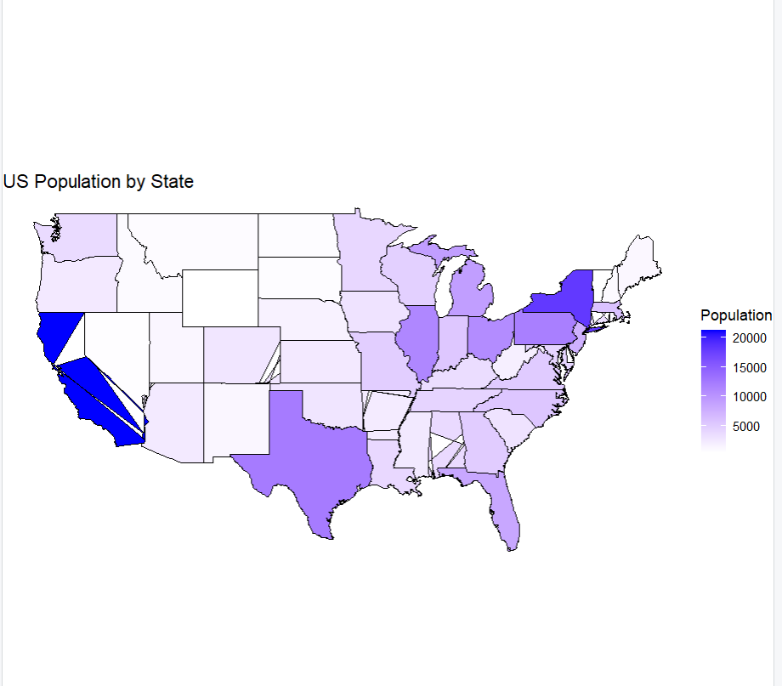
Observation
The standard choropleth represents the actual geographic area of each state, so large states remain visually large even when their populations are relatively small. A population-weighted cartogram would enlarge highly populated states and shrink less populated states, making population differences more visually prominent. Different map projections also change the apparent shape and size of states.

Question 5: 3D Geospatial Heatmap
Language: Python
Dataset provided: volcano_elevation.csv
Load volcano_elevation.csv (columns: x, y, elevation — a 61 × 87 grid representing the Maunga Whau volcano digital elevation model). Pivot the data into a 2D elevation grid and create an interactive 3D surface heatmap using Plotly (plotly.graph_objects.Surface, with a suitable colorscale such as "Earth" or "Viridis" mapped to elevation). Add axis titles and a title, and enable hover tooltips showing elevation at each grid point. Additionally produce a 2D top-down heatmap (e.g., plotly.graph_objects.Heatmap or seaborn.heatmap) of the same data for comparison. In 2–3 sentences, discuss what the 3D surface view reveals about the volcano's shape that the 2D heatmap alone does not (or vice versa).
Skills tested: pandas pivot(), plotly.graph_objects.Surface, 3D colorscales and hover tooltips, 2D heatmap comparison, matplotlib/seaborn or plotly for 2D view.

Code :
import numpy as np
import plotly.graph_objects as go
import matplotlib.pyplot as plt
x=np.arange(61)
y=np.arange(87)
X,Y=np.meshgrid(x,y)
Z=500+300*np.exp(-((X-30)**2/500+(Y-43)**2/900))+50*np.sin(X/8)*np.cos(Y/10)
fig=go.Figure(data=[go.Surface(z=Z,x=x,y=y,colorscale="Earth",hovertemplate="X: %{x}<br>Y: %{y}<br>Elevation: %{z:.2f}<extra></extra>")])
fig.update_layout(title="3D Volcano Elevation Surface",scene=dict(xaxis_title="X",yaxis_title="Y",zaxis_title="Elevation"))
fig.show()
plt.imshow(Z,origin="lower",aspect="auto")
plt.colorbar(label="Elevation")
plt.title("2D Volcano Elevation Heatmap")
plt.xlabel("X")
plt.ylabel("Y")
plt.show()

Output :
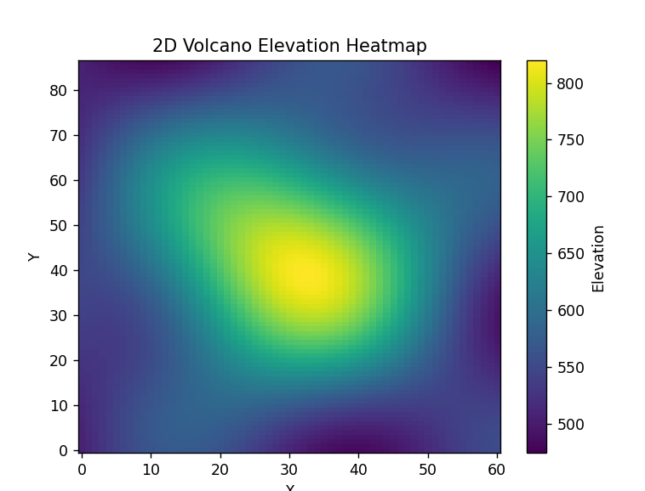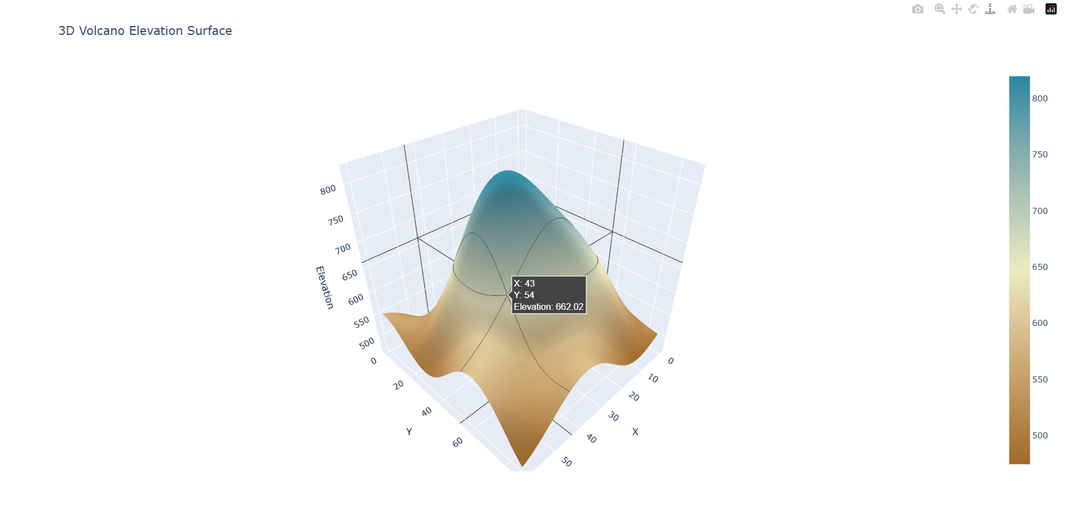

Interpretation
The 3D surface provides a clearer view of the volcano's elevation changes and overall shape because peaks and slopes can be seen spatially. The 2D heatmap is useful for comparing elevation values across the entire grid, but it does not show the three-dimensional shape as clearly.

